

Items highlighted in yellow are tasks for you to complete
Items in Blue are help tips

Tab Settings

Tab settings are one way we can set text out in a structured format. Tab settings help to line up several rows of text at the same spot, which would otherwise be next to impossible just using the space bar. This is because characters take up varying amounts of space. Just look at this paragraph. Count four characters in on the first three lines. You should find that the fifth character is not in the same position on each line.

Can you imagine setting up this table without the use of tabs?

Flight No Date Depart Time Arrive Time
DE1234 3/10/1998 Melbourne 10:15am London 6:35am
HL5463 6/10/1998 London 6:45pm Ireland 7:35pm
DI1789 9/10/1998 Ireland 5:45pm France 7:30pm
MF7658 12/10/1998 France 12:30pm Italy 1:30pm
IR9870 16/10/1998 Italy 10:00pm Germany 11:20pm
GB8756 19/10/1998 Germany 7:30am Holland 9:10am
HH8877 21/10/1998 Holland 7:40pm Switzerland 10:12pm
SW4343 25/10/1198 Switzerland 9:00am Hong Kong 10:00pm
HK0987 26/10/1998 Hong Kong 3:00pm Melbourne 10:00pm

In this section you will

- Work with Default Tabs
- Change the Default Tab settings
- Set and Use Customised Tabs
- Set Leaders with Tabs
- Edit Tab Settings

Using the Default Tabs

The default tab settings are usually 1.27 cm apart. They can be used easily to line up text. The default tab settings are indicated by gray marks on the Ruler.
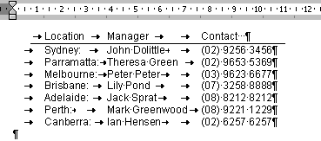
Ruler
Default Tab Settings

- Start a New document
- Press the [Tab] key then type Location
- Press the [Tab] again then type Manager
- Press the [Tab] key twice and type Contact
Using the [Tab] key positions the insertion point at the next tab setting on the ruler.

Location Manager Contact

- Press [Enter] to move to the next line
- Press the [Tab] key then type Sydney:
- Press the [Tab] key twice then type John Dolittle
- Press the [Tab] key once and type (02) 9256 3456
- Press [Enter] to move to the next line

- Continue to enter the text as shown below (Note: sometimes you will need to only press the tab key once to line up the text as shown below)

Location Manager Contact
Sydney: John Dolittle (02) 9256 3456
Parramatta: Theresa Green (02) 9653 5369
Melbourne: Peter Peter (03) 9623 6677
Brisbane: Lily Pond (07) 3258 8888
Adelaide: Jack Sprat (08) 8212 8212
Perth: Mark Greenwood (08) 9221 1229
Canberra: Ian Hensen (02) 6257 6257

Working with Tabs

There are default tab settings on the Ruler bar already set at 1.27 cm. Customised Tabs can also be set up quickly using the Ruler bar or with more features using the Tabs dialog box.

It is useful, if not imperative, that the ruler bar is displayed and the Show/Hide Characters button is on.

- Click on View in the Menu bar

- Check that there is a tick next to Ruler – if there is then the Ruler is on – it should appear at the top of your work area.

- Click on the Show/Hide button to display non-printing characters. Non printing characters are spaces, • , tabs, → ,and enters, ¶
Show/Hide

This button shows all spaces, • , tabs, → ,and enters, ¶ , for new lines on the screen as well as normal text. It is useful to have this turned on so it is clear where the [Tab] key has been used.

Default Tab Settings

[Enter] key

[Tab] key

To Quickly Set Customised Tabs

Customised tab settings can be used to put the tabs exactly where we want them. Tabs can be set quickly on the Ruler bar.

There are four different tabs that can be used.

Left Tab Centered Right Decimal

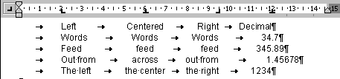This is an example of where the tab settings have been set up on the ruler bar.
Tab type box

- Start a New document
- Click on the Tab type box until the Left tab button appears
- Click on the ruler at 2cm
- Click on the Tab type box until the Centre tab button appears
- Click on the ruler at 6cm
- Click on the Tab type box until the Right tab button appears
- Click on the ruler at 9.5cm
- Click on the Tab type box until the Decimal tab button appears
- Click on the ruler at 12cm

Your ruler should look like the example above. Now we are ready to enter the text

- Press [Tab] to move to the first tab and type Left
- Press [Tab] to move to the second tab and type Centered
- Press [Tab] to move to the third tab setting and type Right
- Press [Tab] to move to the last tab setting and type Decimal
- Press [Enter] to move to the next line, the tab settings will be carried down
- Continue entering text as displayed in the example above

To Clear Tab settings

- Press [Enter] to start a new line

- Click on Format ➢ Tabs ➢ Clear All in the Menu bar to clear the [Tab] settings from a line

NOTE: Quick keys, pressing [Ctrl] & [Q] will do the same job

Practice Exercises

6.1 Set up the following document with tab settings to align the text

Admission Charges

General Member
Adult $25 $20
Child (5-14) $12 $10
Family (2Ad, 2Ch) $50 $40
Concession (PC) $20 $16

6.2 This one is a little harder. Look at how the text is aligned, ie. to the left, right or by decimal and then set the tab at an appropriate spot on the ruler bar

Flight No Date Depart Time Arrive Time
DE1234 3/10/1998 Melbourne 10:15am London 6:35am
HL5463 6/10/1998 London 6:45pm Ireland 7:35pm
DI1789 9/10/1998 Ireland 5:45pm France 7:30pm
MF7658 12/10/1998 France 12:30pm Italy 1:30pm
IR9870 16/10/1998 Italy 10:00pm Germany 11:20pm
GB8756 19/10/1998 Germany 7:30am Holland 9:10am
HH8877 21/10/1998 Holland 7:40pm Switzerland 10:12pm
SW4343 25/10/1198 Switzerland 9:00am Hong Kong 10:00pm
HK0987 26/10/1998 Hong Kong 3:00pm Melbourne 10:00pm

To Set Leaders with Tabs

This example displays a Left tab and a Right tab that is set with Leader dots. A Leader “leads up to” the tab setting it is set with.

Contents Page No

Introduction 1
Chapter One 4
Chapter Two 10
Leader Dots
- Start a New document

- Click on Format➢ Tabs in the Menu bar

The Tabs dialog box is displayed

- 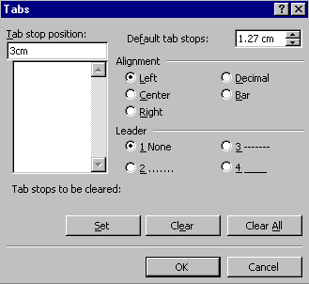Type 3 in the Tab Stop Position text box

- Click on Left in the Alignment box
- Click on in the leader box

- Click on Set – to set the tab

Now set the next tab.
- 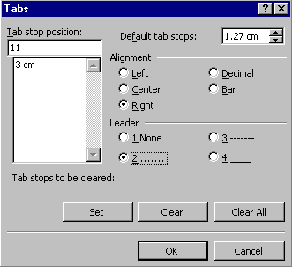Type 11 in the Tab Stop Position box (ignore the 3cm type over the top)

- Click on Right in the Alignment box
- Click on the Leader box

- Click on Set and OK to set the tab and close the Tabs box

The tab settings will appear on the Ruler bar at the top of the work area.

Now we can enter the text.

- Press the [Tab] key once to move to the first tab then type Amusements
- Press [Tab] again to move to the next tab position and type 4
- Press [Enter] to move to the next line – this will carry the tab settings to the next line

- Continue entering text as follows (remember to press [Tab] to start)

Amusements 4
Arts Metro 5
Business C1-5
Comics Metro 2
Crossword Metro 2

To Clear Tab settings

- Press [Enter] to move to a new line then press the [Ctrl] & [Q] keys together

OR

- Press [Enter] to move to the next line that does not need tab settings
- Click on Format ➢ Tabs in the Menu bar
- Click on the Clear All button

Clear All

Page Width Broken Lines

A line that goes all the way across a page is useful for indicating a tear away portion of a page, for example a reply slip or remittance advice.

- Position the Insertion point on the line where the broken line is to appear

- Click on Format ➢ Tabs in the Menu bar
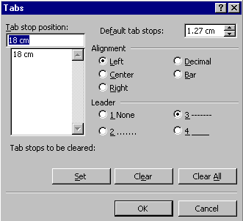
- Set a Tab with a Leader at the right edge of the page, ie 18cm
18cm
Using the Leader creates the broken line

- Drag the Left Indentation marker all the way to the left edge

- Press the [Tab] key once to create a line across the page as shown below

- Press [Enter] then press [Ctrl] & [Q] to clear the settings

Practice Exercises

6.3

Grand Sale Grand Sale Grand Sale Grand Sale Grand Sale Grand Sale
Was Now
Single Cast Iron Beds (2 only) $399 $229
Sofa Bed – Metal Action (1 only) $799 $569
QS Colonial Bed (1 only) $599 $399
QS Cottage Panel Beds (2 only) $599 $399
King Single Wrought Iron Beds (4 only) $329 $199

6.4 This sample will also test your text formatting skills.

ABC Banking Group Statement of Account

Date Transaction Credit Debit Balance
1/1/99 Deposit 1000.00 1000.00
5/1/99 00001 95.95 904.05
10/1/99 00002 55.45 848.60
15/1/99 00004 15.00 833.60
31/1/99 FID 1.57 832.03

Closing Balance 832.03 Cr

To Edit and Adjust Tab Settings

Tab settings can be moved easily just by dragging the tab marker along the ruler bar. However care must be taken if several lines are to be altered. Several lines should be changed together otherwise it can get very messy very quickly.

- Try setting up the following

Number Runner Country Best Time
5 Grit Breuer Germany 49.42
9 Pauline Davis Bahamas 49.85
12 Marie-Jose Perec France 48.83
25 Cathy Freeman Australia 49.59

We can improve the way this looks without starting again

- Highlight all the lines except the heading

The tab marks should appear clearly on the Ruler bar. If they don’t you have too many lines selected, and some of those lines do not have tab settings in the same place as the lines with the athletes.
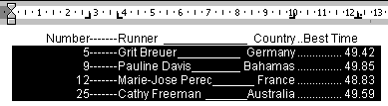

- 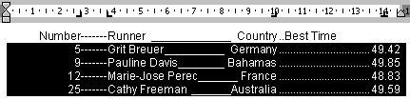Click on the Decimal tab at the far right of the ruler and drag it out along the ruler bar to 14cm

- Click on the third tab and drag it down, right off the ruler bar, your text may go all out of whack but don’t panic
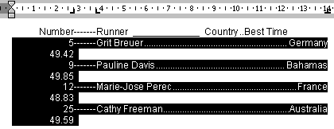

- Click on the Tab type button to the left and display a Left tab setting

- Click on the Ruler bar at 10 cm

Your text will look more orderly and the countries will now line up with the Left tab. Notice that the leaders are gone.
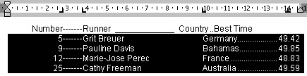
To reinstate these:

- Click on Format ➢ Tabs

- Click on the 10cm tab in the list

- Click on a Leader to set leaders with the 10cm tab setting

- Click on OK

- Finally drag the headings so they also line up in an appropriate position

Number Runner Country Best Time
5 Grit Breuer Germany 49.42
9 Pauline Davis Bahamas 49.85
12 Marie-Jose Perec France 48.83
25 Cathy Freeman Australia 49.59

